**CIRCUIT CONNECTIONS**

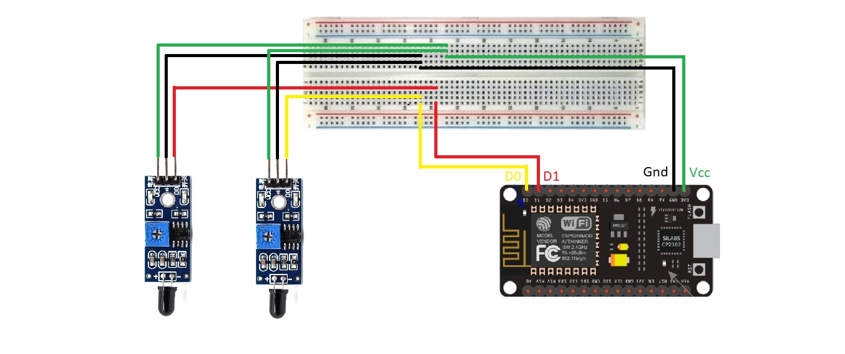

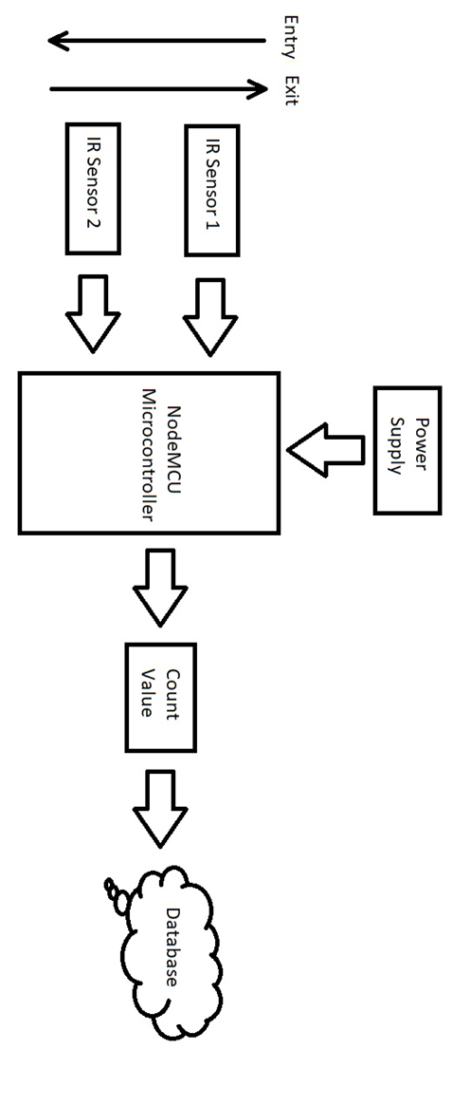**BLOCK DIAGRAM**